***Section* 4.4 – Calculus in Polar Coordinates**

***Slope***

The slope of a polar curve  in the *xy-*plane is still given by , which is not 



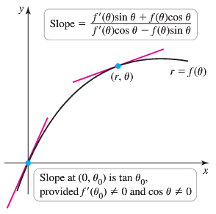







***Example***

Find the points on the interval  at which the cardioid  has a vertical or horizontal tangent line.

***Solution***

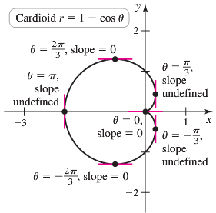











The points with a horizontal tangent line:



The points with a Vertical tangent line:









 Therefore, the curve has a slope of 0 at origin.

**Area in the plane**

The region OTS is bounded by the rays  and the curve .

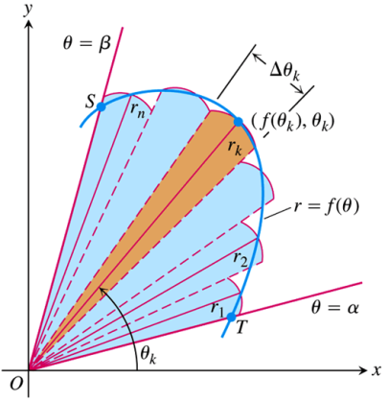

We approximate the region with *n* non-overlapping fan-shaped circular sectors based on a partition *P* of angle *TOS*. The typical sector has radius  and central angle of radian measure . Its area is  times the area of a circle of radius , or



***Area of the Fan-Shaped Region between the Origin and the curve*** 



This is the integral of the ***area differential***



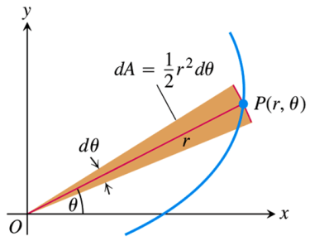

***Example***

Find the area of the region in the plane enclosed by the cardioid 

***Solution***

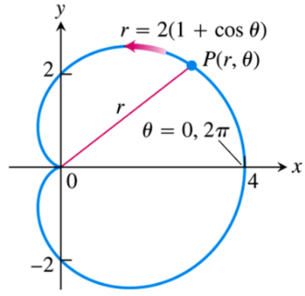













***Area of the Region ***



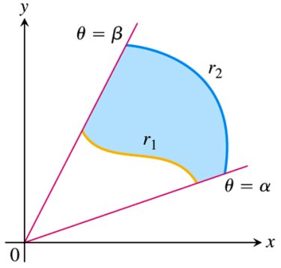

***Example***

Find the area of the region that lies inside the circle  and outside the cardioid 

***Solution***

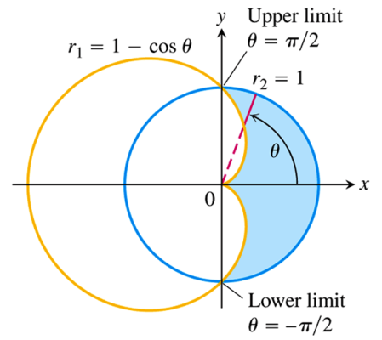













**Length of a Polar Curve**

If  has a continuous first derivative for  and if the point  traces the curve  exactly once as *θ* runs from *α* to *β*, then the length of the curve is



***Example***

Find the length of the cardioid 

***Solution***





 



 

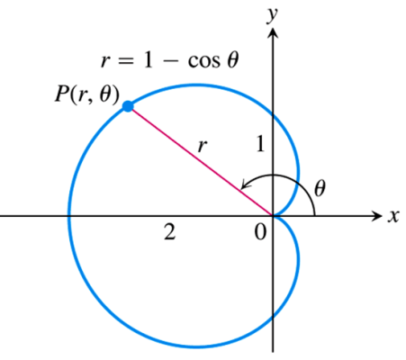 











**Area of a surface of Revolution**

***Theorem***

Let  be a function whose derivative is continuous on an interval  .

The area of the surface formed by revolving the graph of  about the indicated line





***Example***

Find the area of the surface formed by revolving the circle  about the line 

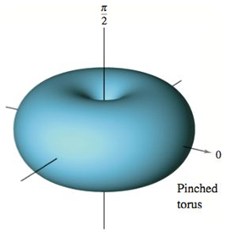 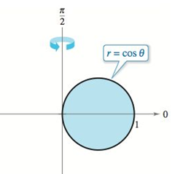

***Solution***













***Exercises*** ***Section* 4.4 – Calculus in Polar Coordinates**

Find the slopes of the curves at the given points. Sketch the curves along with their tangents at these points.

1. 
2. 
3. 
4. 
5. Find the area of the region bounded by the spiral 

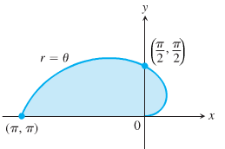

1. Find the area of the region bounded by the circle 



1. Find the area of the region inside one leaf of the three-leaved rose 

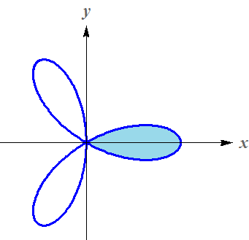

(**8 − 66**) Find the area of the region

1. Inside oval limaçon 
2. Inside Cardioid 
3. Inside Six-leaved rose 
4. Inside curve 
5. Inside right lobe of 
6. Inside Cardioid 
7. Inside Limaçon 
8. Inside circle  above the line 
9. Inside inner loop 
10. Inside One leave of 
11. Shared by the circles 
12. Shared by the circle  and the cardioid 
13. Enclosed by the four-leaf rose 
14. Lies inside the circle  and outside the cardioid 
15. Outside the circle  and inside the circle 
16. Outside the circle  and inside the curve 
17. Inside the circle  in  and inside the right lobe of 
18. Inside the rose  and inside the circle 
19. Inside the lemniscate  and outside the circle 
20. Inside all the leaves of the rose 
21. Inside one leaf of the rose 
22. A complete three-leaf rose 
23. Inside the rose  and outside the circle 
24. Bounded by the lemniscate 
25. Bounded by the limaçon 
26. Bounded by the limaçon 
27. Inside one leaf: 
28. Between inner and outer: 
29. Inner loop of 
30. Inner loop of 
31. Inner loop of 
32. Inner loop of 
33. Between the loops 
34. Between the loops 
35. Between the loops 
36. Between the loops 
37. Inside  and outside 
38. Inside  and outside 
39. Common interior of  and 
40. Common interior of  and 
41. Common interior of  and 
42. Common interior of 
43. Common interior of 
44. Common interior of 
45. Inside  and outside 
46. Inside  and outside 
47. Common interior of  and 
48. Common interior of  and , where  .
49. Enclosed by all the leaves of the rose 
50. Enclosed by the limaçon 
51. Inside limaçon  and outside the circle 
52. Inside lemniscate  and outside the circle 
53. Inside both cardioids  and 
54. Inside the cardioid  and outside the cardioid 
55. Inside both cardioids  and 
56. common interior of  and 
57. Inside both cardioids  and 
58. Common interior  and 
59. Outside  and inside 

(**67 − 89**) Find the length of

|  |  |
| --- | --- |
|  | 8. one petal 9. Inner loop |

(**90 − 95**) Find the surface area bounded by

1. 
2. 
3. 
4. 
5. 
6. 
7. Find the surface area of the torus generated by revolving the circle given by  about the line 
8. Find the surface area of the torus generated by revolving the circle given by  about the line , where 
9. Let *a* and *b* be positive constants. Find the area of the region in the first quadrant bounded by the graph of the polar equation



1. Assume *m* is a positive integer
2. Even number of leaves: what is the relationship between the total area enclosed by the 4*m*-leaf rose  and *m*?
3. Odd number of leaves: what is the relationship between the total area enclosed by the -leaf rose  and *m*?
4. Let  be the region bounded by the nth turn and the  turn of the spiral  in the first and second quadrants, for 

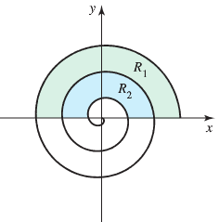

1. Find the area  of .
2. Evaluate 
3. Evaluate 
4. The curve represented by the equation , where *a* and *b* are constants, is called a logarithmic spiral. The figure shows the graph of . . Find the area of the shaded region.

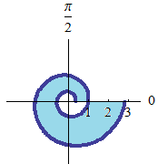

1. The larger circle in the figure is the graph of .

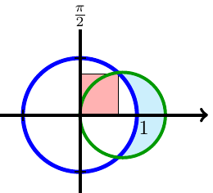

Find the polar equation of the smaller circle such that the shaded regrions are equal.

1. Find equations of the circles in the figure.

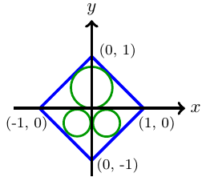

Determine whether the combined area of the circles is greater than or less than the area of the region inside the square but outside the circles.

1. A circular corral of unit radius is enclosed by a fence. A goat inside the corral is tied to the fence with a rope of length .

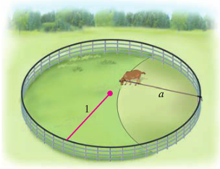

What is the area of the region (inside the corral) that the goat can graze? Check your answer with the special cases  and 

1. A circular corral of unit radius is enclosed by a fence. A goat outside the corral is tied to the fence with a rope of length . What is the area of the grassy region (outside the corral) that the goat can reach?

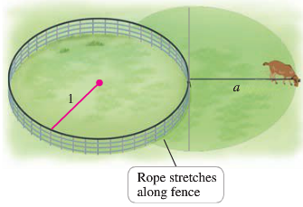

1. A circular concrete slab of unit radius is surrounded by grass. A goat is tied to the edge of the slab with a rope of length .

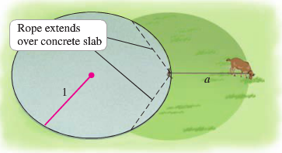

What is the area of the grassy region that the goat can graze? Note that the rope can extend over the concrete slab. Check your answer with the special cases  and 

1. When recording live performance, sound engineers often use a microphone with a cardioid pickup pattern because it suppresses noise from the audience. Suppose the microphone is placed 4 *m* from the front of the stage and the boundary of the optimal pickup region is given by the cardioid , where r if measured in meters and the microphone is at the pole.

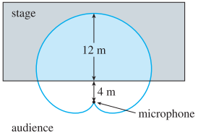

The musicians want to know the area they will have on stage within the optimal pickup range of the microphone, Answer their question.

1. The curve given by the parametric equations



1. Find the rectangular equation of the strophoid.
2. Find a polar equation of the strophoid.
3. Sketch a graph of the strophoid.
4. Find the equations of the two tangent lines at the origin.
5. Find the points on the graph at which the tangent lines are horizontal.
6. Let a polar curve be described by  and let  be the line tangent to the curve at the point 

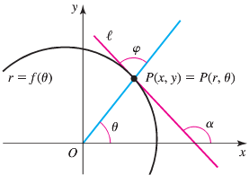

1. Explain why 
2. Explain why 
3. Let  be the angle between  and the line *O* and *P*. Prove that 
4. Prove that the value of *θ* for which  is parallel to the *x-*axis satisfy 
5. Prove that the value of *θ* for which  is parallel to the *y-*axis satisfy 